This is address for the site for the Ramle Junior High English material.
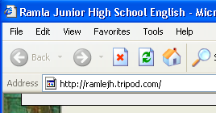

Look for the section on the 8th grade and click on it
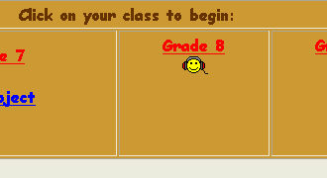

Click on the timetable link
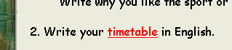

Then you must click on שמירה בשם (SAVE AS). The name used should be that of the person doing the work and their class number – Haim 7-5

Finally open the document in WORD and work on it. Remember to save every few minutes.

highlight
To translate first the word to be translated go to the menu called (כלים)TOOLS then use the Dictionary to translate the word. Finally replace the word in Hebrew with the English word in the Dictionary.

