SEVEN STEPS TO A PERFECT PRESENTATION

STEP 1 - After turning on the program, choose to make a BLANK presentation.
Then press OK

STEP 2 - Choose a style for the slide from the menu. Then press OK
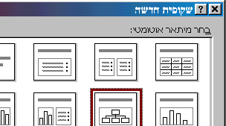

Add text, pictures and sound as desired. Each slide can have a different style. Change how things appear using the Format (עצוב) menu as in Word.

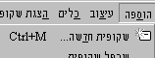
STEP 3 - From the INSERT (הוספה) menu, add another slide or as many as needed.

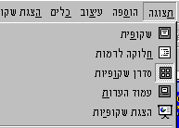
STEP 4 – To see all the slides, look at all the slides on the Slide Sorter (סדרן) under the View (תצוגה) menu. choose the effects and transitions you want. To change an individual slide look at each one separately. You can also add notes that will not be seen while the presentation is being shown.

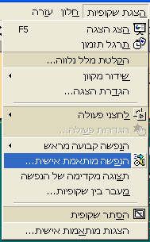
STEP 5 – Add a variety of effects and transitions from the VIEW SLIDES (הצגת שקופיות) menu.
- Animation (הנפשה) controls how each slide appears. You can choose animations that are suggested or make your own.
- Transition (מעבר בין שקופיות) controls the appearance of each slide one after the other.
- Create an automatic presentation by timing (תרגל תזמון) the slides.

STEP 6 – Choose effects and order the presentation in the screen below after choosing ANIMATION (הנפשה מותאמת אישית) menu.

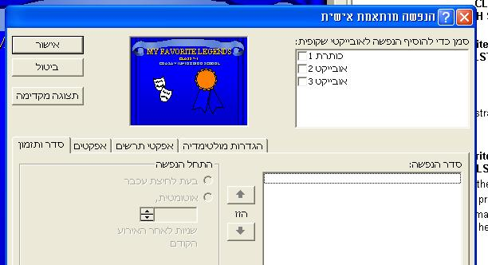

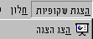
STEP 7 - Check to see the entire presentation is properly designed by viewing it as a slide presentation (הצג הצגה).

Press the ESC key at any time to return to the "drawing board" for more formatting or effects.

